Web Conventions
Section: Backend
- For every application the following namespace and defined structure should be used. If you are building an ERP system called “MR”, there should be the project structure and namespace. Create a folder called MR, create a solution called MR.MBL (MR = M&R Company, MBL = Client Company/Project Name )and add the following projects
  - MR.MBL.Web
  - MR.MBL. Api
  - MR.MBL.Service
  - MR.MBL.DataAccess
  - MR.MBL.Model

- Use Pascal Casing for class names and method names, this is consistent with the Microsoft's .NET Framework and easy to read.
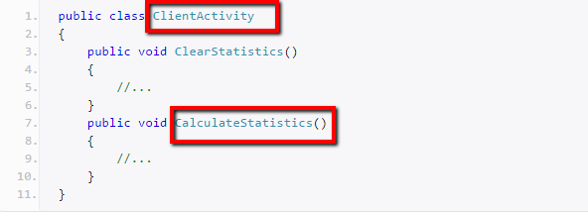
- Use noun or noun phrases to name a class, this is consistent with the Microsoft's .NET Framework and easy to remember.

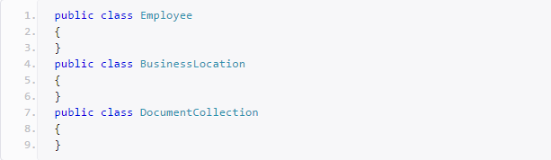
- Use camelCasing for method arguments and local variables, this is consistent with the Microsoft's .NET Framework and easy to read.
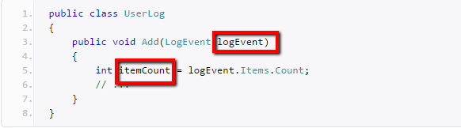

- Use predefined type names instead of system type names like Int16, Single, UInt64, etc. This is consistent with the Microsoft's .NET Framework and makes code more natural to read.
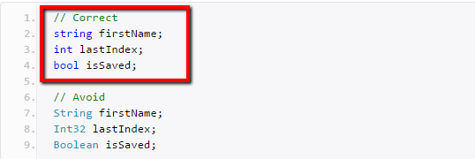

- Declare all member variables at the top of a class, with static variables at the very top, this prevents the need to hunt for variable declarations.
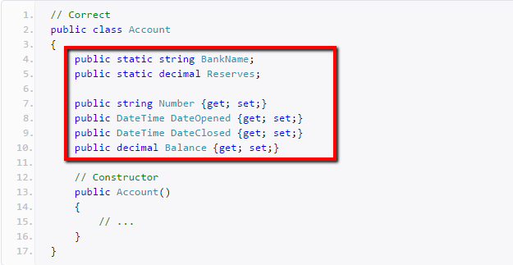

- Try to declare variable using specific types if known.(eg: int personId, string name etc). If unknown, Use implicit type var for variable declarations.
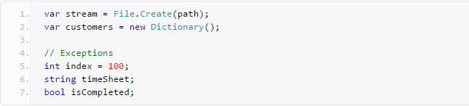

- Always use vertically align curly brackets
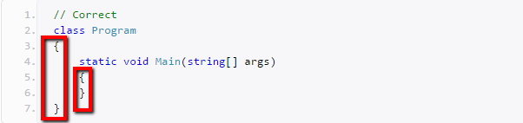

- Use singular names for enums and do not explicitly specify a type of an enum or values of enums.
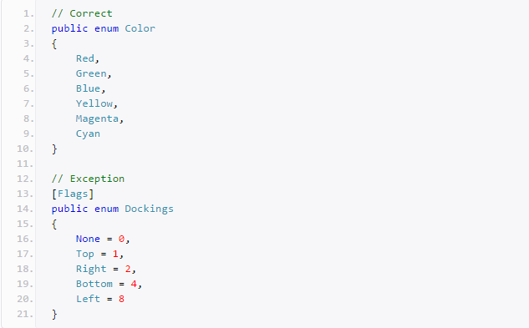

- Prefix interfaces with the letter I. Interface names are noun (phrases) or adjectives. All classes in Service Project must implement Interface.
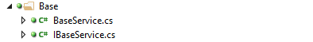

- ActionProc (Procedure) helps run a stored procedure that does not return any data. All action procedure must use IDataAccessService to get the adapter and pass this adapter as a parameter, see example as follows.
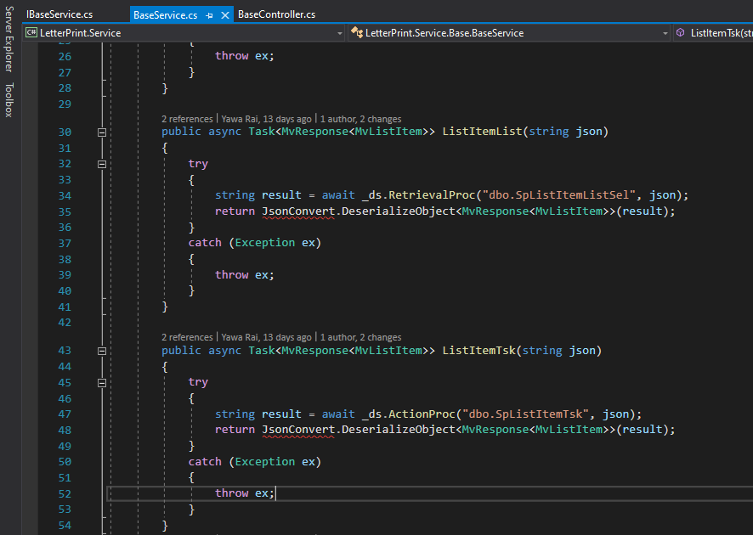

- RetrievalProc (Procedure) returns data, use the IDataAccessService as follows to return derived model


Section: Frontend
- While creating a component for ‘login’, the folder name should be ‘login’.
It should contain following files :
a) login.component.html
b) login.component.ts
c) login.component.scss
d) login.service.ts (Optional)
e) login.model.ts (Optional)
f) login.module.ts
g) login.component.spec.ts (For unit testing purpose)
Note: Most of the files will be automatically generated by Angular Item templates extension.
- All the applications should be inside ‘app’ folder. The sub-modules or feature should be created inside the particular application folder. For eg: account => login.
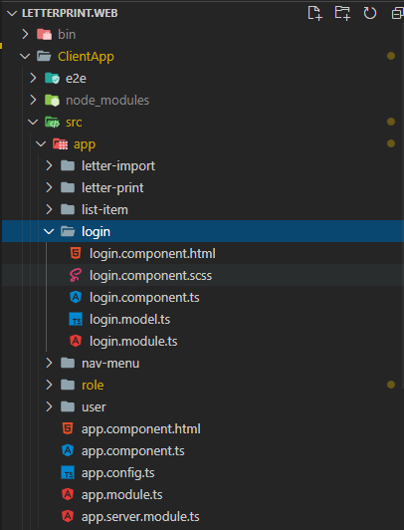
- All the core (shared) files should be under ‘core’ folder
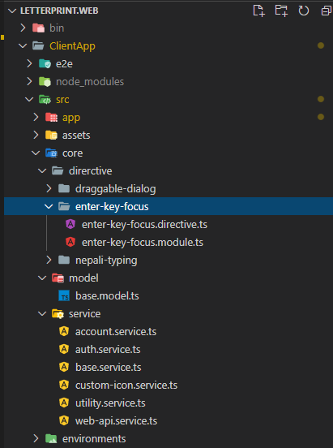

- All the shared components (used in multiple locations) and controls (custom controls like dropdown,grid,tree-view etc) should be under shared folder.
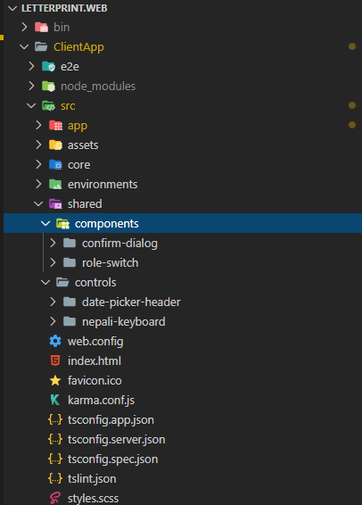
- While creating interface in .model.ts file , the interface name should be prefixed with MvLogin. Property name of the interface should be PascalCase.
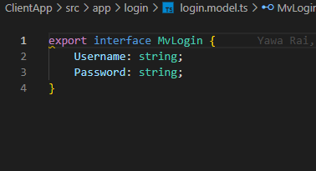
- All the variables(global), input, output etc. should be declared before the constructor
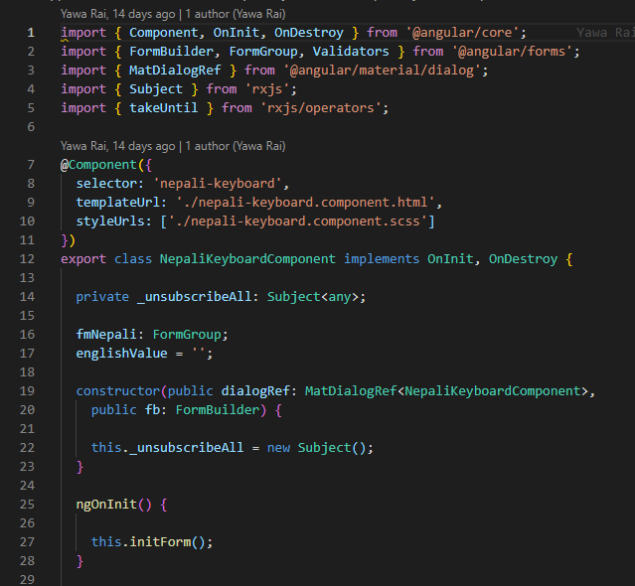
- Try to declare variable using specific types if known.(eg: personId : number, name : string etc). If unknown, Use implicit type any for variable declarations. The variables should be in camelCase.
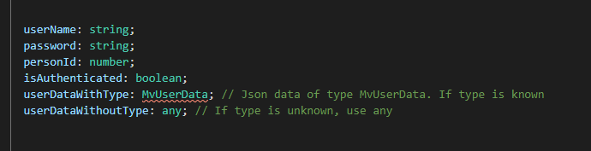
- While declaring CSS class name, all the class names should be in lowercase. If a class name has multiple words, then it should be separated by ‘-’
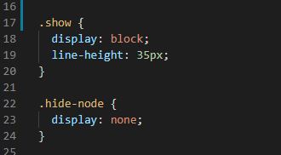
- The component selector should be in lowercase separated by ‘-’ and prefixed with ‘zen-’ for shared components.
- 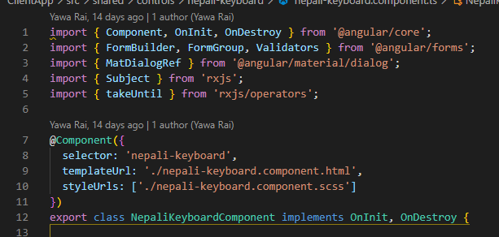
- All the inputs, output and function declaration should be in camelCase
